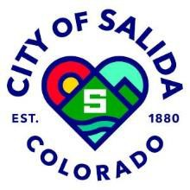 | SUSTAINABILITY COMMITTEE
 | 448 E. 1st Street, Council Chambers, Salida, Colorado 81201
 | April 10, 2024 - 4:15 PM

AGENDA

MEETING MINUTES
- Approve March 15, 2024 Meeting Minutes

UNFINISHED BUSINESS
- Electric ready v. Electric preferred
  - Greg Follet led discussion on the Energy Code
  - Matt Nykiel to speak on Energy Amendments
- Updates on Water Bottle Fill Station

NEW BUSINESS
- Strategic Planning Updates: Resources, Groups and how is it going?
UPDATES
- Earth Day: April 22nd at Centennial Park
- Sustainability Committee: May 8th
- Arbor Day: May 11th at S Mountain

ADJOURN

