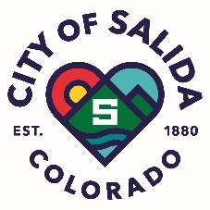 Elected Officials Terms of Office

Elected Official | Position Held | Ward | First Elected | Second Term | Term | End of Current Term | Term Limited In
Dominique Naccarato | City Council | One | 2021 | n/a | 4 yr. | 2025 | 2029
Suzanne Fontana | City Council | One | 2023 | n/a | 4 yr. | 2027 | 2031
Aaron Stephens | City Council | Two | 2023 | n/a | 4 yr. | 2027 | 2031
Justin Critelli | City Council | Two | 2017 | 2021 | 4 yr. | 2025 | 2025
Alisa Pappenfort | City Council | Three | 2019 | 2023 | 4 yr. | 2027 | 2027
Harald Kasper | City Council | Three | 2017 | 2021 | 4 yr. | 2025 | 2025
Dan Shore | Mayor | n/a | 2021 | n/a | 2 yr. | 2025 | 2027
Ben Gilling | Treasurer | n/a | 2023 | n/a | 4 yr. | 2027 | 2031

