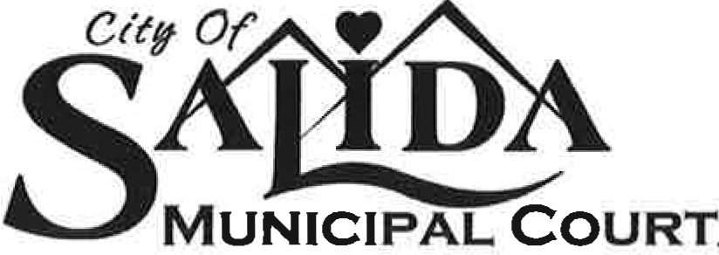

USE THIS letter for all unpaid tickets written after 12/2/21

Insert CURRENT DATE that this letter is going to be mailed out! Date will trigger the 10 days.

Insert Name
and
address of registered owner of vehicle

RE: Notice of Liability by Default

Dear Sir or Madame:

Our records indicate that the following citation(s) were issued to a vehicle registered in your name. It has now been in excess of 20 days since this citation was issued. Per Salida Municipal Code 8-1-30 (a) (5) and (a) 10.5, a Default Judgment shall issue for any parking citations not paid within 14 days of issuance; as a courtesy the Court has waited a full 20 days before issuing your Notice of Default Judgment. Court costs of $35 (fines and surcharge) are added onto unpaid fines after 20 days. A judgment of liability by default has now issued against you by the Court. Payment in full of unpaid costs and fines will cure a default.

License Date Time Location Citation Fines and Costs Due

If you deny or contest liability for this citation, you do have the right to file a written petition to the Court to set aside your Default within 10 days after the date of mailing of this Notice. If granted by the Court, you will be notified and a bench trial will be scheduled for your personal appearance on a date certain where the judge will take sworn testimony of you and any other witnesses. If no such written petition is filed and granted, the Default Judgment issued per this letter shall become final and referred to Collections. Your failure to appear at any scheduled trial will reinstate your default judgment. All unpaid fines and costs will be reported to collections.

You may avoid this matter being reported to collections if, within 45 days after the date of mailing of this Notice, you make payment in full of the total fines and costs. Your check or money order should be made payable to the Salida Municipal Court, Ste. 112, 448 E. 1st Street, Salida, CO 81202. Please note your license plate number on your check or money order as well as your parking ticket’s citation number. You may also pay via credit card online via the link found of the Municipal Court website at www.cityofsalida.com (look for “How Do I?” on the dropdown menu on the city’s homepage for a payment link; you will need your ticket’s citation number).

If you have a question about procedure, please first read through www.cityofsalida.com (go to the Municipal Court/parking section). Thereafter, if you still have procedural questions you may email the Clerk at kathy.smith@cityofsalida.com. Court staff is unable to give legal advice and can only discuss procedure with you and Court staff has no authority to negotiate your citation.

Very truly yours,

Clerk, Salida Municipal Court

448 E. FIRST STREET • SUITE 112 • SALIDA, COLORADO 81201
PH: 719.530.2611 • FAX: 719.539.5271

