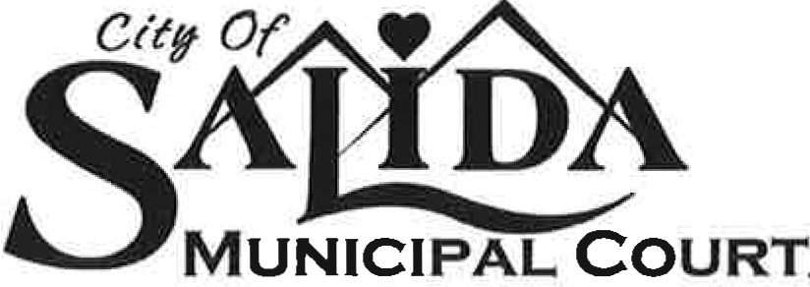

USE THIS letter for all NON PARKING, unpaid traffic infraction tickets that have had their Court date and due to fta, declared to be in default. Start using even for those who were noted in default b/c of failing to appear 12/17/21.

Insert CURRENT DATE that this letter is going to be mailed out! Date will trigger the 10 days for petition.

Insert Name
and
address

RE: Notice of Entry of Judgment of Civil Liability by Default

Dear Sir or Madame:

A Judgment of Civil Liability by Default has been ordered by the Judge against you due to your failure to appear in Court per directives on your traffic citation or otherwise handle your City of Salida traffic infraction matter.

Date Time Infraction Citation No. Points Fines and Costs Due

Per SCC 8-1-30(a)(5), you may file a written petition with the Clerk of the Court within ten (10) days after the date of this letter requesting that the Court set aside your default. This letter starts a strict 10 day time period that started with the date of this letter. You may email your petition to the Court Clerk (kathy@cityofsalida.com), hand deliver to the Court Clerk, use the City’s C Street drop box to the attention of the Court Clerk, or use (snail) U.S. Mail. If the petition is timely filed within the ten days, you will be notified of a new hearing date at which time you will have the ability to speak with the City Prosecutor and judge about your ticket. If you fail to act or fail to appear at a newly scheduled hearing, the Default Judgment previously entered shall become final. Once a Default Judgment is final, points associated with your offense(s) will be reported to the Colorado Department of Revenue (DOR) and fines and court costs will be referred to Collections. If you hold a non-Colorado license, the Colorado DOR may report these points to your state’s licensing authority.

To avoid being reported to Collections you may make payment in full for your total fines and costs at any time without need to return to Court. Points, once assessed, shall remain unchanged. Your check or money order should be made payable to the Salida Municipal Court, Ste. 112, 448 E. 1st Street, Salida, CO 8120. Please note your license plate number on your check or money order as well as your ticket’s citation number. You may also pay via credit card online via the link found of the Municipal Court website at www.cityofsalida.com (look for “How Do I?” on the dropdown menu on the city’s homepage for a payment link; you will need your ticket’s citation number).

If you have a question about procedure, please first read through the Salida Municipal Court section at www.cityofsalida.com. Thereafter, if you still have procedural questions you may email the Clerk at kathy.smith@cityofsalida.com. Court staff is unable to give legal advice and can only discuss procedure with you and have no authority to negotiate your citation.

Very truly yours,

Clerk, Salida Municipal Court

448 E. FIRST STREET • SUITE 112 • SALIDA, COLORADO 81201
PH: 719.530.2611 • FAX: 719.539.5271

